Memory Organization in Computer Architecture

A memory unit is the collection of storage units or devices together. The memory unit stores the binary information in the form of bits. Generally, memory/storage is classified into 2 categories:

* **Volatile Memory**: This loses its data, when power is switched off.
* **Non-Volatile Memory**: This is a permanent storage and does not lose any data when power is switched off.

## Memory Hierarchy

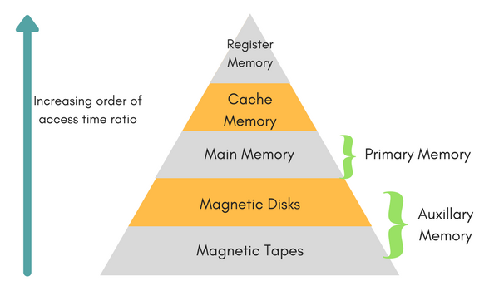

The total memory capacity of a computer can be visualized by hierarchy of components. The memory hierarchy system consists of all storage devices contained in a computer system from the slow Auxiliary Memory to fast Main Memory and to smaller Cache memory.